**The Lord’s Day**

**January 26, 2025**

**Announcements / Looking Ahead**

*This Tuesday:* Women’s Bible Study

*Next Sunday*: Communion / Potluck

*Feb 7-8*: Men’s Conference @ Le Mars Bible Church

**Ongoing Ministries**

**Every Sunday:** *Fellowship & Prayer, 9:00 a.m.*

*Sunday School, 9:35-10:20 a.m.*

*Worship Service, 10:30 a.m.*

**Wednesday nights (**school year**):** *Pathfinders / Youth Group, 6:30 p.m.*

**First Sunday of the Month:**  *Communion & Potluck*

**Last Tuesday of the month:** *Women’s Bible Study, 6:30 p.m.*

**Please Keep Our Missionaries in your Prayers**

John **Florey** (SDSU) Todd & Karen **Indehar** (Thailand)

David & Beth **Roberts** (Uruguay) Peter & Kathlyn **Scarborough** (Lebanon)

Have a praise/prayer request? Special Need? Please contact **Pastor Rich**:

**Email:** richardldecker@gmail.com

**Cell Phone:** 712-899-7217 | **Office Phone:** 605-874-8182

**First Baptist Church**

**Our Mission**

*To bring glory to God by proclaiming Jesus Christ and being transformed by his Word and Spirit as his disciples.*

***Today’s Order of Service***

**Call to Worship**

**Opening Songs**

*His Mercy Is More--------------------------------------------------------------* Slides

*Grace -----------------------------------------------------------------------------* Slides

*Not What My Hands Have Done --------------------------------* Black Hymnal #94

**Prayer & Praise**

**Sermon**

*God’s Righteousness Revealed 1 --------------------------------* Romans 3:21-24

**Closing Song**

*His Robes for Mine* *---------------------------------------------* Black Hymnal #48

**Benediction**

**PRAYER REQUESTS / PRAISES**

____________________________________________________________________________________________________________________________________________________________________________________________________________________________________________________________________________________________________________

**SERMON NOTES**

________________________________________________________________________________________________________________________________________________________________________________________________________________________________________________

_______________________________________________________________________________________________________________________________________________________________________________________________________________________________________________

________________________________________________________________________________________________________________________________________________________________________________________________________________________________________________

________________________________________________________________________________________________________________________________________________________________________________________________________________________________________________

________________________________________________________________________________________________________________________________________________________________________________________________________________________________________________________________________________________________________________________________________________________________________________________________________________________________________________________________________________________________________________________________________________________________________________________________________________________________________________________________________________________________________________________________________________________________________________________________________________________________________________________________________________________________________________________________________________________________________________________________________________________________________________________________________________________________________________________

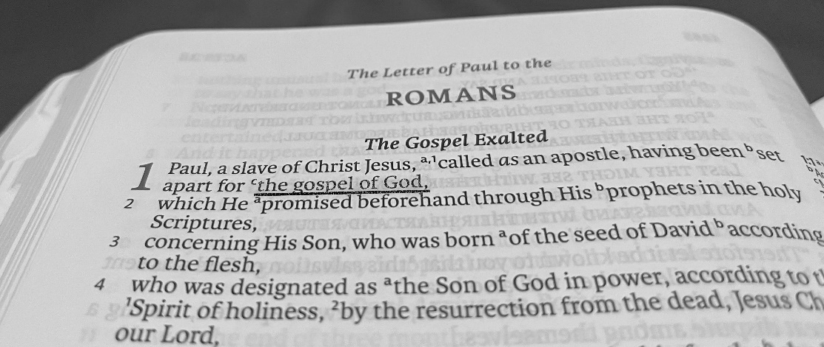

But God demonstrates His own love toward us,

in that while we were yet sinners, Christ died for us.

*- Romans 5:8 (LSB)*

**First Baptist Church**

**Clear Lake, SD**

***www.fbcclearlake.com***